Ideation Phase Empathize & Discover

|  |  |
| --- | --- |
| Abishek K | 45254CE0E5C084FA0EE4CF87784FD96F |
| Abin Raj R | 4318E2FC0901E3D94C945AE9925B83BE |
| Sanjay J K | 02CC36AAF94156E977D4B41C8EA26BC3 |
| Hari Viknesh M | 30D3B956BF07E8E8A9642F779692D927 |

# Empathy Map Canvas:

An empathy map for e-voting using blockchain can help understand the needs and behaviors of users, including voters, election officials, developers, and blockchain experts.

The empathy map for e-voting using blockchain highlights the need for a system that is secure, transparent, and easy to use for all stakeholders involved in the voting process. By understanding the needs and behaviors of users, developers can design and build a system that meets these requirements and ensures the integrity of the voting process. The pain points and gains identified in the empathy map can help guide the development of the e-voting system and ensure that it meets the needs of all stakeholders.

**Empathy Map for e-voting using blockchain**

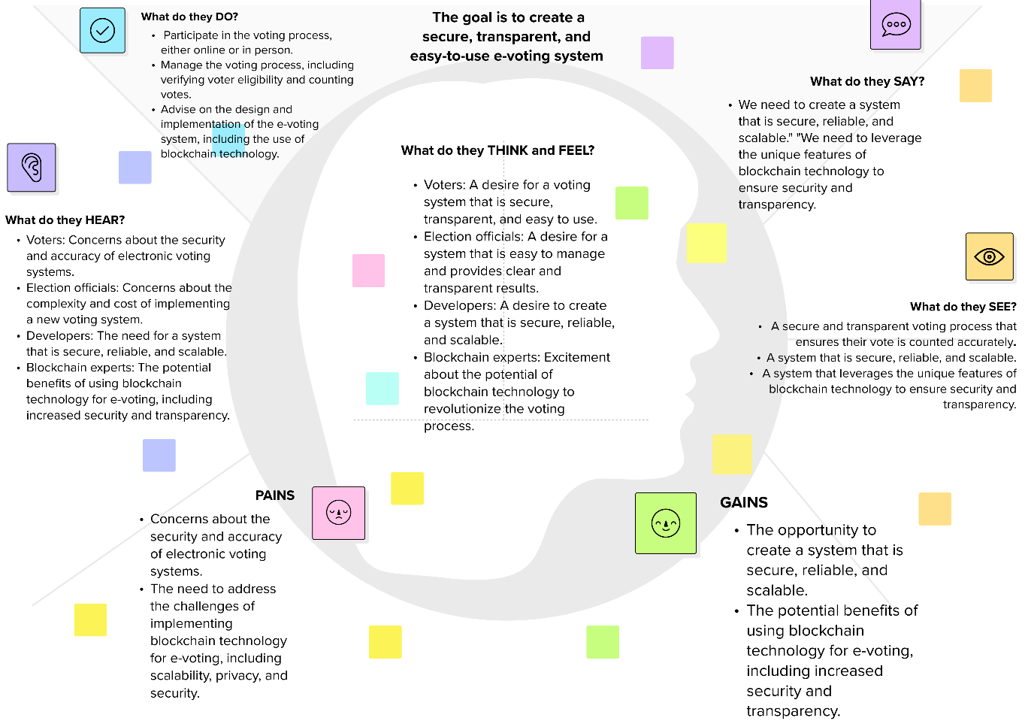

**INTRODUCTION**

* 1. **Project Overview**

This project aims to develop an electronic voting system using blockchain technology. The system will provide transparency, security, and privacy while ensuring fairness and flexibility in the voting process. In response to the persistent challenges faced by traditional electronic voting systems, this project introduces a cutting-edge solution by integrating blockchain technology. The aim is to enhance the security, transparency, and overall integrity of the electoral process.

* 1. **Purpose**

The purpose of this project is to address the existing problems in traditional voting systems, such as vote rigging, hacking, and election manipulation, by implementing a blockchain-based e-voting system. The proposed solution will provide a secure and transparent voting process that can be accessed from anywhere with an internet connection.  By leveraging blockchain, we aim to establish an immutable and transparent ledger that can withstand tampering and enhance voter confidence.

**LITERATURE SURVEY**

**2.1 Existing problem**

Traditional voting systems have several issues, including vote rigging, hacking, and election manipulation. These problems can lead to a lack of transparency and fairness in the voting process, which can undermine the legitimacy of the election results. The current challenges in electronic voting systems, such as susceptibility to tampering and lack of transparency, necessitate a paradigm shift. The literature survey explores the drawbacks of conventional systems and the potential benefits of integrating blockchain.

**2.2 References**

Several researchers have proposed blockchain-based e-voting systems that can address the existing problems in traditional voting systems. Crypto-voting is an e-voting system that uses permissioned blockchain technology and two blockchains that are linked. The first blockchain records voting procedures and voters, while the second counts the votes and provides results. The system shows the importance of anonymization of the network consensus nodes, and voting procedures and results are done by smart contracts[2]. Another proposed solution is DVTChain, a blockchain-based decentralized mechanism that ensures the security of digital voting systems. A comprehensive list of references is provided to support the project's foundations, drawing on key academic and industry insights in the fields of electronic voting and blockchain technology.

**2.3 Problem Statement Definition**

The problem statement precisely outlines the deficiencies in current electronic voting systems, laying the groundwork for the proposed blockchain-based solution. The problem statement is to develop a secure and transparent electronic voting system that can address the existing problems in traditional voting systems, such as vote rigging, hacking, and election manipulation, by implementing blockchain technology.

**IDEATION & PROPOSED SOLUTION**

**3.1 Empathy Map Canvas**

An empathy map is created to understand the needs, concerns, and expectations of key stakeholders in the electoral process. This canvas informs the design and implementation of the proposed solution.The empathy map canvas will help us understand the needs and concerns of the voters, election officials, and other stakeholders involved in the voting process.

**3.2 Ideation & Brainstorming**

Based on the empathy map canvas, we will brainstorm and ideate the features and functionalities of the proposed blockchain-based e-voting system.

**REQUIREMENT ANALYSIS**

**4.1 Functional requirement**

The functional requirements of the proposed system include user registration, authentication, and verification, secure and transparent voting process, vote counting, and result declaration. This section outlines the specific functionalities that the blockchain-based electronic voting system must encompass to address identified issues and meet user expectations.

**4.2 Non-Functional requirements**

The non-functional requirements of the proposed system include security, privacy, scalability, usability and usability criteria, are defined to ensure a well-rounded and effective solution.

**PROJECT DESIGN**

**5.1 Data Flow Diagrams & User Stories**

Visual representations of data flow and user stories are presented to provide a clear understanding of how the system will operate and cater to user needs.The data flow diagrams and user stories will help us visualize the flow of data and the interactions between the users and the system.

**5.2 Solution Architecture**

The architecture of the proposed solution, detailing the integration of blockchain, is explained to elucidate the system's structure and functionality.The solution architecture will define the components and their interactions in the proposed blockchain-based e-voting system.

**PROJECT PLANNING & SCHEDULING**

**6.1 Technical Architecture**

The technical architecture of the project is outlined, including the technologies and frameworks used to implement the blockchain-based electronic voting system. The technical architecture will define the hardware and software requirements for the proposed system.

**6.2 Sprint Planning & Estimation**

Sprint planning and estimation strategies are detailed, ensuring a systematic and efficient development process. The sprint planning and estimation will help us break down the project into smaller tasks and estimate the time and effort required for each task.

**6.3 Sprint Delivery Schedule**

The sprint delivery schedule will define the timeline for completing each task and delivering the project. A schedule of sprint deliveries is provided, offering a timeline for the project's completion and key milestones.

**CODING & SOLUTIONING**

The proposed system will be developed using blockchain technology, smart contracts, and frontend technologies. The features added to the project will include user registration, authentication, and verification, secure and transparent voting process, vote counting, and result declaration.

**7.1 Feature 1**

User registration, authentication, and verification will ensure that only eligible voters can participate in the voting process.

**7.2 Feature 2**

Secure and transparent voting process will ensure that the votes are counted correctly, and the results are declared fairly.

**7.3 Database Schema**

The performance metrics will include response time, throughput, and resource utilization.

**PERFORMANCE TESTING**

**8.1 Performance Metrics**

Metrics for performance testing are defined, ensuring that the blockchain-based electronic voting system meets the required standards of speed, reliability, and scalability.The performance metrics will include response time, throughput, and resource utilization.

**RESULTS**

**9.1 Output Screenshots**

The output screenshots will show the user interface and the results of the voting process.

**ADVANTAGES & DISADVANTAGES**

* The advantages of the proposed blockchain-based e-voting system include transparency, security, and privacy.
* The disadvantages include the complexity of the system and the potential for errors in the smart contracts.

**CONCLUSION**

In conclusion, the proposed blockchain-based e-voting system can address the existing problems in traditional voting systems and provide a secure and transparent voting process. However, further research is needed to address the open research challenges and differing opinions on the feasibility of using blockchain for electronic voting systems.

**FUTURE SCOPE**

Source Code

GitHub & Project Demo Link

Ideation Phase

Brainstorm & Idea Prioritization Template

# Brainstorm & Idea Prioritization Template:

Brainstorming provides a free and open environment that encourages everyone within a team to participate in the creative thinking process that leads to problem solving. Prioritizing volume over value, out-of-the-box ideas are welcome and built upon, and all participants are encouraged to collaborate, helping each other develop a rich amount of creative solutions.

Use this template in your own brainstorming sessions so your team can unleash their imagination and start shaping concepts even if you're not sitting in the same room.

# Step-1: Team Gathering, Collaboration and Select the Problem Statement

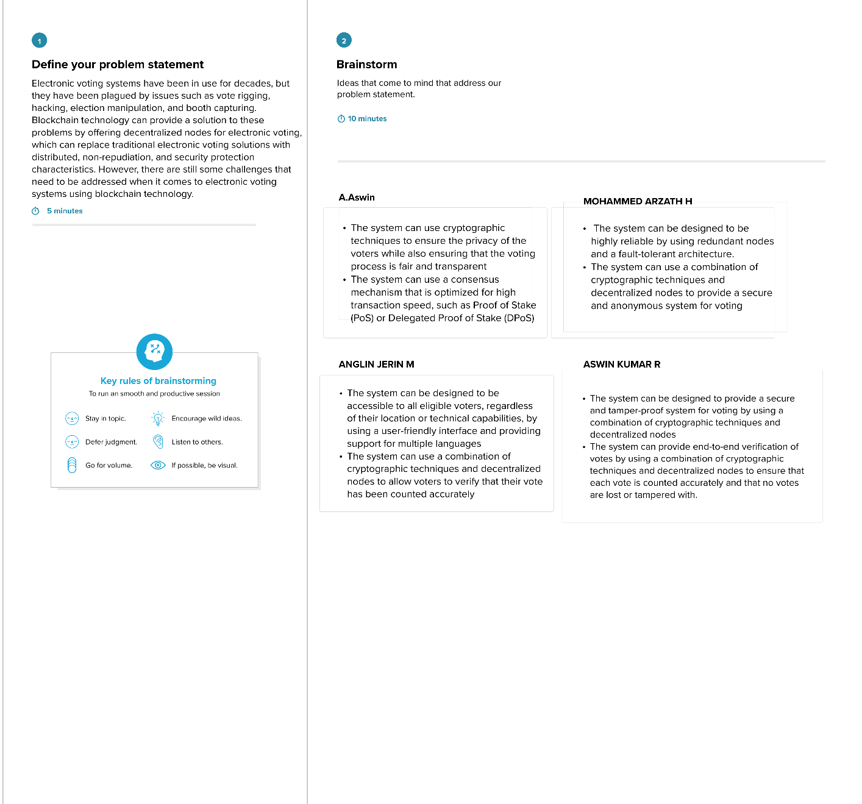

**Step-2: Brainstorm, Idea Listing and Grouping**

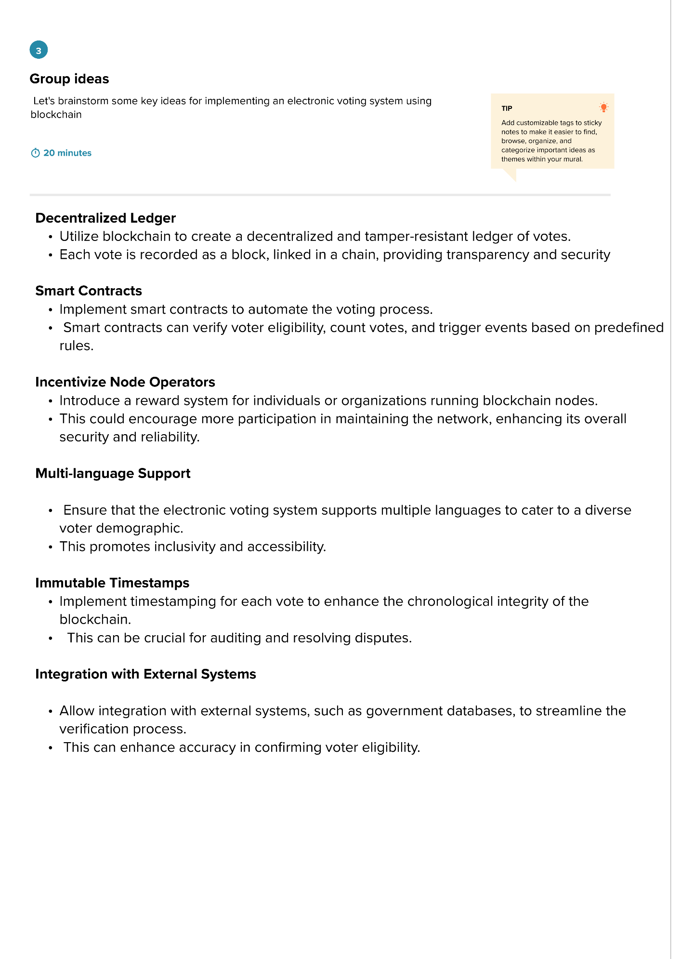

**Step-3: Idea Prioritization**

